Query the list of CITY names from **STATION** that do not end with vowels. Your result cannot contain duplicates.

**Input Format**

The **STATION** table is described as follows:

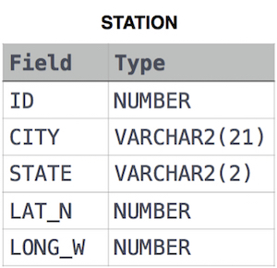

where LAT_N is the northern latitude and LONG_W is the western longitude.

Ans:

select distinct CITY from STATION where

CITY not like '%a' and

CITY not like '%e' and

CITY not like '%i' and

CITY not like '%o' and

CITY not like '%u';